**CAP 774: STYLING AND SCRIPTING FOR WEB DEVELOPMENT**

**CONTINUOUS ASSESSMENTS (C.A)-1**

**ST_NAME : - EKHLAKH AHMAD**

**REG NO. : - 12209166**

**ROLL NO. : - RD2215B58**

**SECTION : - D2215**

**GROUP : - 2**

**Q.2. Create Table:**

**OUTPUT**

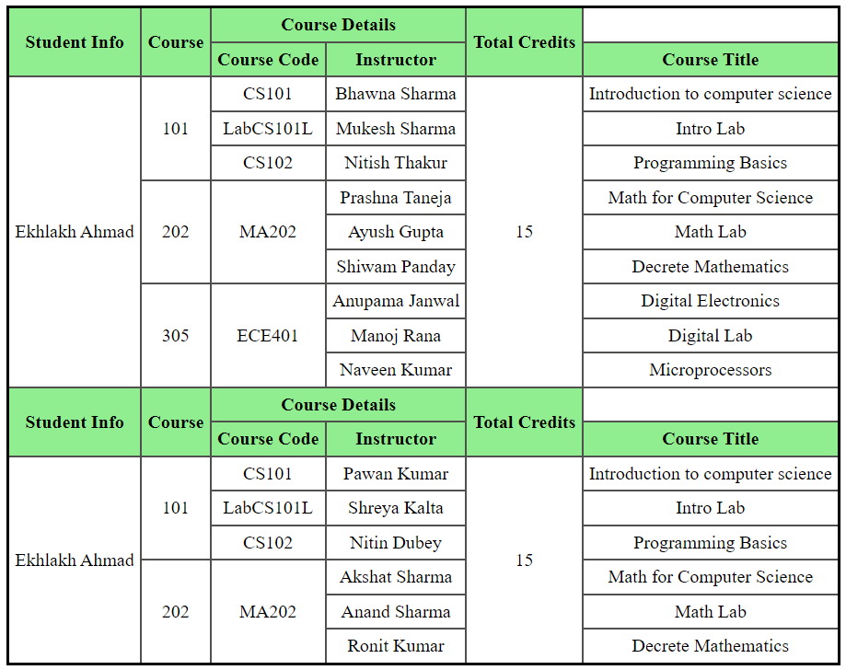

**CODING**

<!DOCTYPE html>

<html lang="en">

<head>

<meta charset="UTF-8">

<meta name="viewport" content="width=device-width, initial-scale=1.0">

<title>Table</title>

<style>

body{

text-align:center;

}

table,th,td{

border-collapse: collapse;

border: 3px solid black;

padding: 5px;

}

th,td{

border: 2px solid rgb(82, 79, 79);

}

th{

background-color: lightgreen;

}

</style>

</head>

<body>

<center>

<table>

<tr>

<th rowspan="2">Student Info</th>

<th rowspan="2">Course</th>

<th colspan="2">Course Details</th>

<th rowspan="2">Total Credits</th>

</tr>

<tr>

<th>Course Code</th>

<th>Instructor</th>

<th>Course Title</th>

</tr>

<tr>

<td rowspan="9">Ekhlakh Ahmad</td>

<td rowspan="3">101</td>

<td>CS101</td>

<td>Bhawna Sharma</td>

<td rowspan="9">15</td>

<td>Introduction to computer science</td>

</tr>

<tr>

<td>LabCS101L</td>

<td>Mukesh Sharma</td>

<td>Intro Lab</td>

</tr>

<tr>

<td>CS102</td>

<td>Nitish Thakur</td>

<td>Programming Basics</td>

</tr>

<tr>

<td rowspan="3">202</td>

<td rowspan="3">MA202</td>

<td>Prashna Taneja</td>

<td>Math for Computer Science</td>

</tr>

<tr>

<td>Ayush Gupta</td>

<td>Math Lab</td>

</tr>

<tr>

<td>Shiwam Panday</td>

<td>Decrete Mathematics</td>

</tr>

<tr>

<td rowspan="3">305</td>

<td rowspan="3">ECE401</td>

<td>Anupama Janwal</td>

<td>Digital Electronics</td>

</tr>

<tr>

<td>Manoj Rana</td>

<td>Digital Lab</td>

</tr>

<tr>

<td>Naveen Kumar</td>

<td>Microprocessors</td>

</tr>

<tr>

<th rowspan="2">Student Info</th>

<th rowspan="2">Course</th>

<th colspan="2">Course Details</th>

<th rowspan="2">Total Credits</th>

</tr>

<tr>

<th>Course Code</th>

<th>Instructor</th>

<th>Course Title</th>

</tr>

<tr>

<td rowspan="9">Ekhlakh Ahmad</td>

<td rowspan="3">101</td>

<td>CS101</td>

<td>Pawan Kumar</td>

<td rowspan="9">15</td>

<td>Introduction to computer science</td>

</tr>

<tr>

<td>LabCS101L</td>

<td>Shreya Kalta</td>

<td>Intro Lab</td>

</tr>

<tr>

<td>CS102</td>

<td>Nitin Dubey</td>

<td>Programming Basics</td>

</tr>

<tr>

<td rowspan="3">202</td>

<td rowspan="3">MA202</td>

<td>Akshat Sharma</td>

<td>Math for Computer Science</td>

</tr>

<tr>

<td>Anand Sharma</td>

<td>Math Lab</td>

</tr>

<tr>

<td>Ronit Kumar</td>

<td>Decrete Mathematics</td>

</tr>

</table>

</center>

</body>

</html>

**Q.2. Create you are a student in a lpu computer science department, and you have been assigned a project to create a personal webpage using HTML & CSS. the webpage should showcase your skills, interests, and achievements.**

**requirements:**

**page heading, Profile Image, Skills and Interests, Education, and Projects.**

**Coding**

<!DOCTYPE html>

<html lang="en">

<head>

<meta charset="UTF-8">

<meta name="viewport" content="width=device-width, initial-scale=1.0">

<title>CA-I</title>

<style>

body{

margin: 0;

padding: 0;

font-family: sans-serif;

}

header{

background-color: #333;

color: white;

padding: 2px;

text-align: center;

}

footer{

background-color: #333;

color: white;

padding: 10px;

text-align: center;

}

span a{

margin: 40px;

}

b{

font-size: large;

font-weight: bolder;

}

</style>

</head>

<body>

<header>

<h1>Master in Computer Application</h1>

<p>Ekhlakh Ahmad</p>

</header>

<h2>Skill and Interests:</h2>

<h3>Technical Skills</h3>

<ul>

<li>C</li>

<li>C++</li>

<li>JAVA</li>

<li>PYTHON </li>

</ul>

<h3>Web-Technology</h3>

<ul>

<li>HTML</li>

<li>CSS</li>

<li>JAVASCRIPT</li>

</ul>

<h3>Hobbies</h3>

<ul>

<li>Always kwow about technical

app...

</li>

<li>reading book</li>

</ul>

<dl>

<dt>Higher Education</dt>

<dd>Master in Computer Application, From Lovely Professional University, Punjab</dd>

</dl>

<dl>

<dt>Graduation Degree</dt>

<dd>Bachelor in Computer Application From Maulana Mazharul Haque Arabic & Parsian University, Patna</dd>

</dl>

<table border="1px" cellpadding="15px" cellspacing="2px">

<tr>

<th colspan="4" bgcolor="yellow"><b>My Education Details:</b></th>

</tr>

<tr >

<th>Serial No.</th>

<th>Class</th>

<th>Board / University</th>

<th>Passing Year</th>

</tr>

<tr>

<td>1.</td>

<td>MCA</td>

<td>LPU</td>

<td>2024</td>

</tr>

<tr>

<td>2.</td>

<td>BCA</td>

<td>MMHAPU</td>

<td>2021</td>

</tr>

<tr>

<td>3.</td>

<td>12th</td>

<td>BSEB, Patna</td>

<td>2018</td>

</tr>

<tr>

<td>4.</td>

<td>10th</td>

<td>BSEB, Patna</td>

<td>2016</td>

</tr>

</table>

<h1>Projects:</h1>

<p>Calculator</p>

<ul>

Description:

<li>simple Calculator using HTML & CSS</li>

<li>you can some basic operation </li>

<li>addition, subtraction, multiplication, and division</li>

</ul>

<ul>

Technologies used:

<li>HTML, CSS and JavaScript</li>

</ul>

<footer>

<h2>Contact Information:</h2>

<span><a href="mailto:ekhlakhahmadpc@gmail.com">ekhlakhahmadpc@gmail.com</a></span>

<span><a href="tel:9576650491">+91 9576650491</a></span>

<span><a href="https://wa.me/9576650491" target="_blank">WhatsApp</a></span>

</footer>

</body>

</html>

**OUTPUT**

